Title of the Contribution Font size16 Align Left
Author’s Name 12 Left
Author’s Address, e-mail 10 Left
Abstract (9 Italics): 150-200 words are required. Include the aim, method, and the main outcome of the paper.
Keywords (9 Italics): 4-7 keywords. Use semicolon to separate the keywords

1 First-Level Heading 14

1.1 Second-Level Heading 12

1.1.1 Third-Level Heading 10
10 Justify. Please use font type Times Roman CE only (Author, 2021). The structure of the paper should be the following: Introduction; Literature Review; Methods; Results; Discussion; Conclusion; Acknowledgements; References
text text text text text text text text text text text text text text text text text text text text text text text text text text text text text text text text text text.
$μ_{A}\left(x,y\right)$ (3)

1.1.2 Third-Level Heading
text text text text text text text text text text text text text text text text text text (Kiss – Kovács, 2018). text text text text text text text text text text text text text text text text text text. text text text text text text text text text text text text text text text text text text text (Kepler et al. 2019).
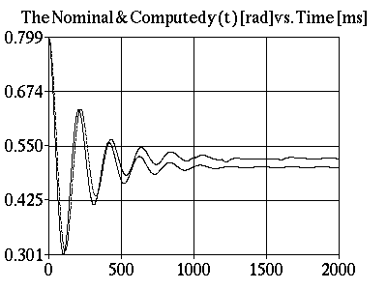
Figure 1
The trajectory tracking
text text text text text text text text text text text text text text text text text text text text text text text text text text text text text text text text text text.
Conclusions 10
text text text text text text text text text text text text text text text text text text text text text text text text text text text text text text.
Acknowledgement 10
text text text text text text text text text text text text text text text text text text text text text text text text text text text text text text.
References 10
The references should be given in alphabetical order.
- Author, X. (2021): Title, in Proceedings of …, place and date of edition, pp.
- Kiss T. – Kovacs I. (2018): Title. Journal, 7(8), pp. 23-32.
- Kepler T. – Teller K. – Neuman I. (2019): Book Title. 3rd edition, Smart Publisher, pp. 23-32.

foot note 9 text text text text text text text text text text text text text text text text text text text text text text. Avoid using footnotes.

